**Retail Business Performance Analysis Report**

**Introduction**

This report presents a comprehensive analysis of the retail dataset with the objective of uncovering actionable insights related to profitability, seasonal trends, and inventory management. The analysis was conducted using MySQL for data cleaning and Power BI for data visualization.

**Methodology**

1. **Data Cleaning**:
   * Null values in Profit and Inventory Days were removed using MySQL.
   * The Season column was created using DAX in Power BI to categorize each order by the corresponding season based on the Order Date.
2. **Tools Used**:
   * **MySQL Workbench**: For initial data exploration and preprocessing.
   * **Power BI**: For visualization and dashboard creation.
   * **Python (Pandas, Seaborn**): For correlation between inventory days and profitability.
3. **Calculated Fields**:
   * **Profit Margin** = Profit / Sales
   * **Season** column generated from Order Date using DAX:
   * Season = SWITCH(TRUE(),
   * MONTH(' Superstore_Clean '[OrderDate]) IN {12,1,2}, "Winter",
   * MONTH(' Superstore_Clean '[OrderDate]) IN {3,4,5}, "Spring",
   * MONTH(' Superstore_Clean '[OrderDate]) IN {6,7,8}, "Summer",
   * MONTH(' Superstore_Clean '[OrderDate]) IN {9,10,11}, "Fall"
   * )

**Key Findings**

1. **Least Profitable Categories/Sub-Categories**

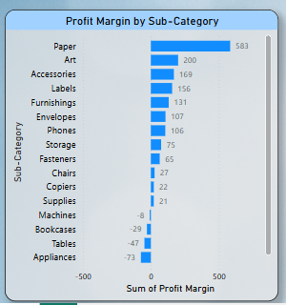

* Categories and sub-categories with the lowest average profit margins were identified.

**Key Insight**: In the "Office Supplies" category "Blinders", "Appliances" and in the "Furniture" category "Tables”, “Bookcases" sub-category consistently showed low profit margins across all regions.

1. **Seasonal Trends**

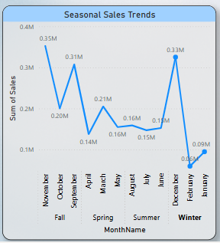

* Seasonal sales analysis showed a spike in certain product categories during specific seasons.
* **Key Insight**: Notable increase in sales during **winter** and **fall** seasons. Electronics and Furniture sales peak during November–December, indicating strong holiday demand.

1. **Inventory Days vs Profit Margin**

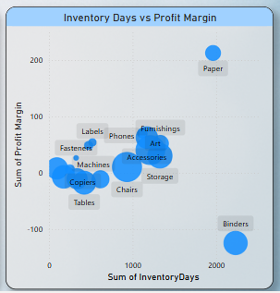

* A scatter plot showed which products have high inventory days and low profit margins.
* **Key Insight**: Several "Office Supplies" and "Furniture" items are overstocked and underperforming.  
  **Items with high holding time but poor returns:**
* "Office Machines" – High stocking cost, minimal sales
* "Paper and Envelopes" – Low profitability and slow movement

**4. KPI Summary**

* **Total Sales**: ₹2.30M
* **Total Profit**: 286.40K
* **Average Inventory Days**: 3.96 Days

**Recommendations**

1. **Discount Strategies**:
   * Offer targeted discounts on slow-moving items with high inventory days.
   * Consider clearance sales for underperforming product lines.
2. **Stock Reduction**:
   * Reduce inventory levels for items with poor profit margins to free up capital.
   * Implement Just-in-Time (JIT) inventory for stationary and office supplies.
3. **Product Bundling**:
   * Bundle underperforming products with high-performing ones to increase overall value.
   * Example: Combine envelopes with premium stationery sets.
4. **Seasonal Marketing**:
   * Launch targeted campaigns in high-performing seasons (Winter/Fall).
   * Promote electronics and furniture aggressively during holiday periods.

**Conclusion**

This analysis highlights several actionable opportunities to optimize retail performance. By implementing discount strategies, adjusting stock levels, and leveraging seasonal trends, the business can improve profitability and reduce inventory inefficiencies. Further analysis on customer demographics and regional performance is recommended for deeper strategic planning.

**End of Report**